**DAILY ASSESSMENT FORMAT**

|  |  |  |  |
| --- | --- | --- | --- |
| **Date:** | **July 1, 2020** | **Name:** | **Persis P** |
| **Course:** | **61st IIRS Outreach programme** | **USN:** | **4AL17EC069** |
| **Topic:** | **Concepts of Satellite Photogrammetry** | **Semester & Section:** | **6th sem & B sec** |
| **Github Repository:** |  |  |  |

|  |
| --- |
| **AFTERNOON SESSION DETAILS** |

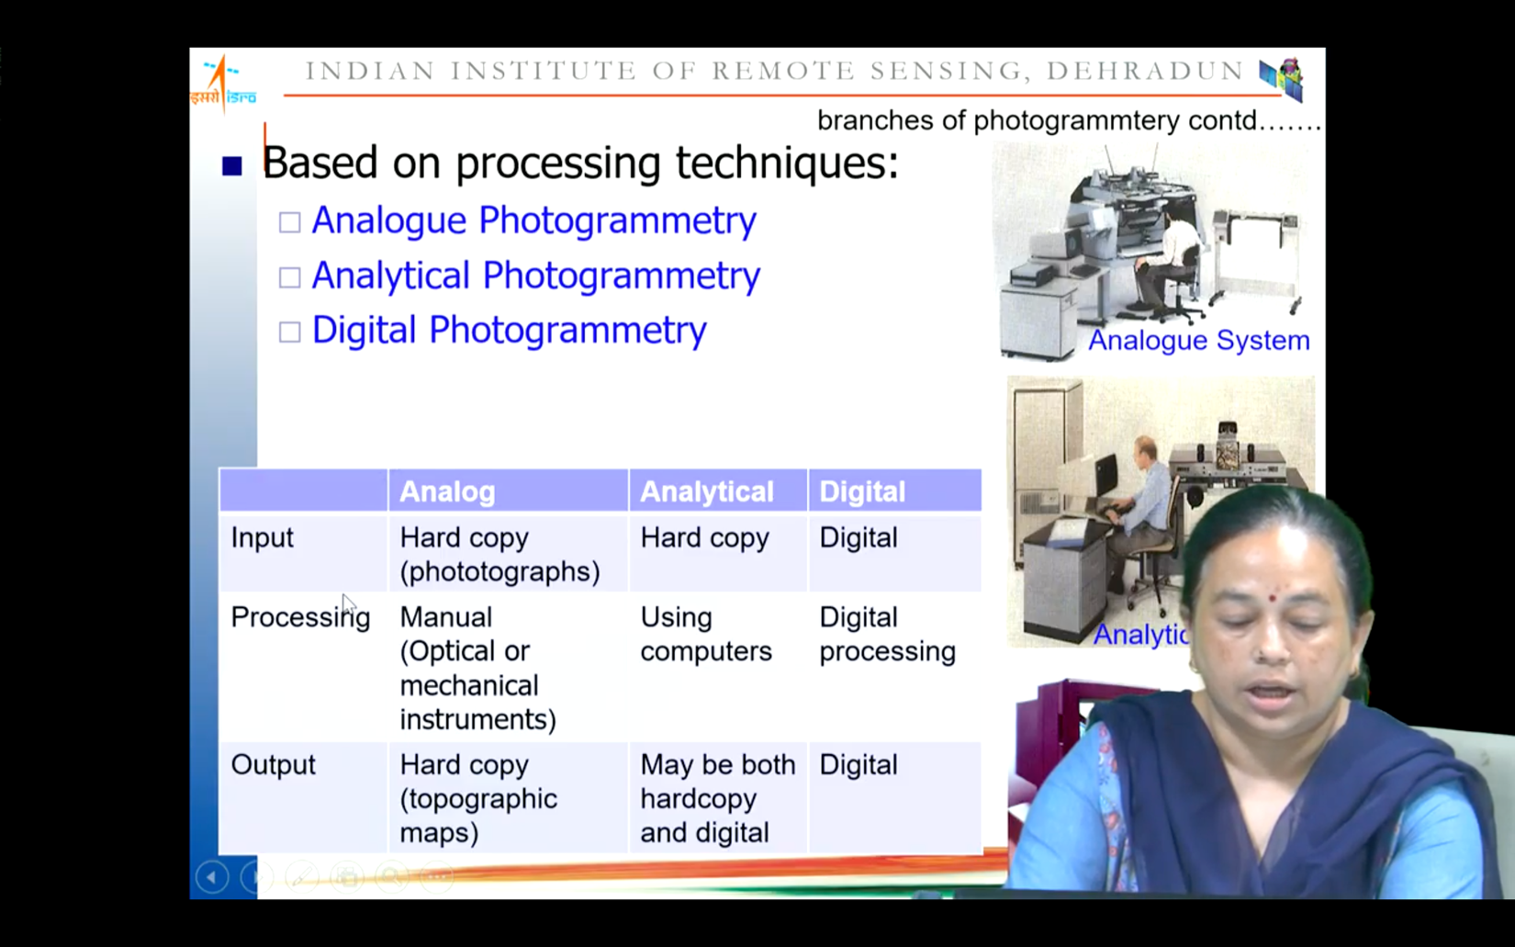

**Branches of Photogrammetry**

1. Based on platform:

* Ground based
* UAV/drone based
* Aerial Photogrammetry
* Satellite Photogrammetry

1. Based on processing techniques:

* Analogue Photogrammetry
* Analytical Photogrammetry
* Digital Photogrammetry

**Satellite Photogrammetry**

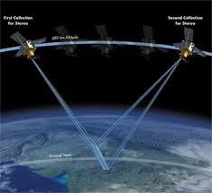Advantages of imaging from space:

* Synoptic view
* Large swath, repeativity
* Constant scale, near orthonormal

projection

* Negligible internal distortions
* Stable radiometry
* Formalities associated with aerial photography and flight arrangement are avoided here

**Stereo Imaging & topographic mapping**

Stereo imaging refers to the aspect of sound recording and reproduction of stereophonic sound concerning the perceived spatial locations of the sound source(s), both laterally and in depth.

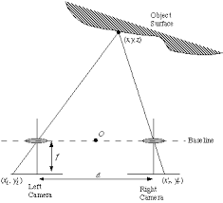

* Light rays in a bundle defined by the sensor are almost parallel - lessening

The importance of the satellite’s position.

* The inclination angles of the cameras onboard the satellite become the critical data.
* A stereo scene is achieved when two images of the same area are acquired on different days from different orbits, one taken east of the other. For this to occur, there must be significant differences in the inclination angles.

**Stereo coverage**

Two possible configurations:

* Across-track stereo
* Along-track stereo

**Across-track stereo –** the pointing of the imaging sensor is oriented off-nadir in the across-track direction.

**Along-track stereo** – stereo coverage is obtained during the flight along the same orbit either by:

-using at least two sensors oriented off-nadir in the along-track direction with different angles of view

-by changing the pointing angle of one sensor along the orbit

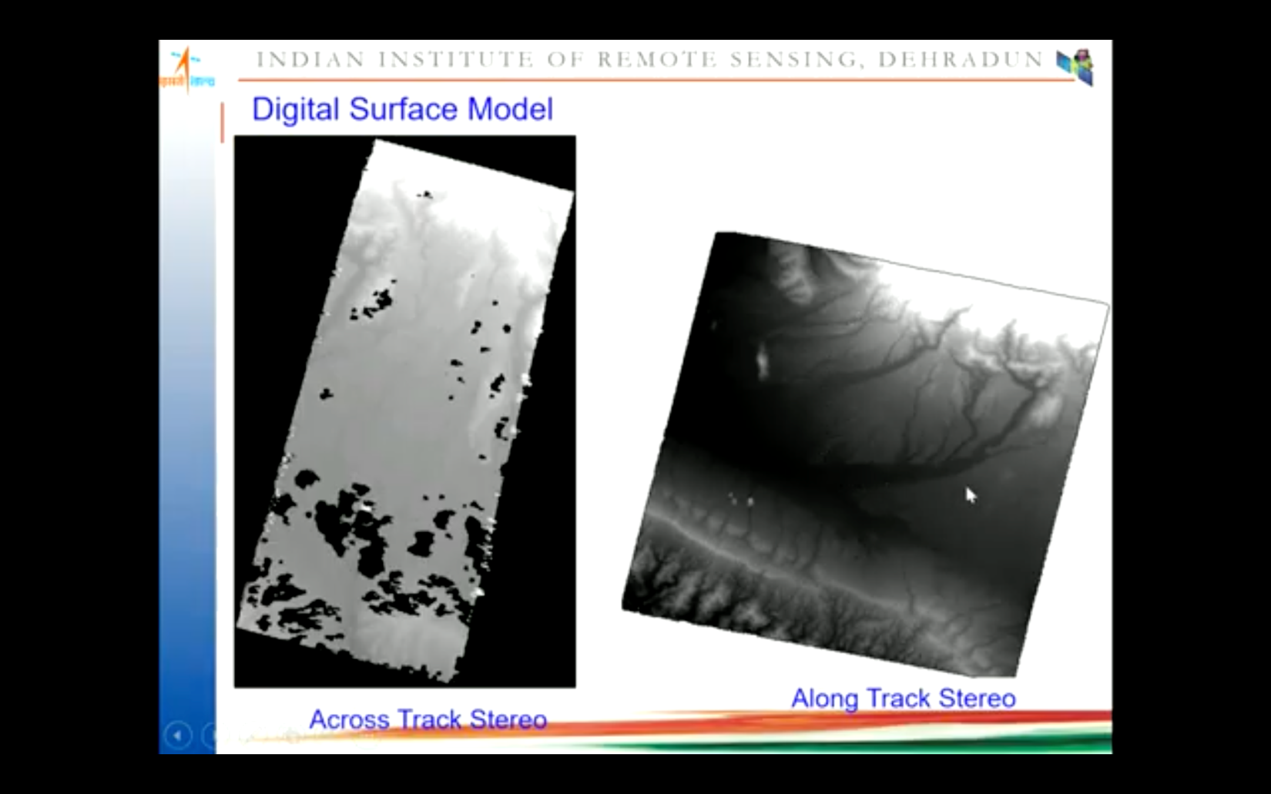

**Image acquisition methodology**

A method comprises exposing an image sensor, reading a charge on the image sensor and performing analog-to-digital conversion, where a charge of pixels on a partial region of the photosensitive sensor is read by means of pixel binning according to data characteristics of an image of a target scene, and obtaining a target image of the target scene according to the read charge.

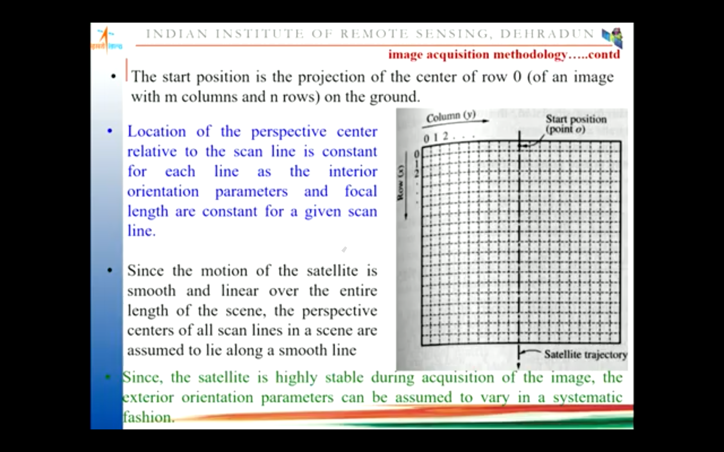

**Modelling satellite sensor orientation**

Modelling satellite sensor motion & orientation in space is one of the preliminary tasks that should be performed for using satellite image data for any application.

